It is generated from maternal plasma, and passes through the fetal membranes by osmotic and hydrostatic forces.
amniotic fluid is more hypotonic than fetal plasma

FUNCTIONS OF Amniotic fluid
- Protecting the fetus: The fluid cushions the baby from outside pressures, acting as a shock absorber.
- Temperature control: The fluid insulates the baby, keeping it warm and maintaining a regular temperature.
- Infection control: The amniotic fluid contains antibodies.
- Lung and digestive system development: By breathing and swallowing the amniotic fluid, the baby practices using the muscles of these systems as they grow.
- Muscle and bone development: As the baby floats inside the amniotic sac, it has the freedom to move about, giving muscles and bones the opportunity to develop properly.
- Lubrication Amniotic fluid prevents parts of the body such as the fingers and toes from growing together; webbing can occur if amniotic fluid levels are low.
- Umbilical cord support: Fluid in the uterus prevents the umbilical cord from being compressed. This cord transports food and oxygen from the placenta to the growing fetus.

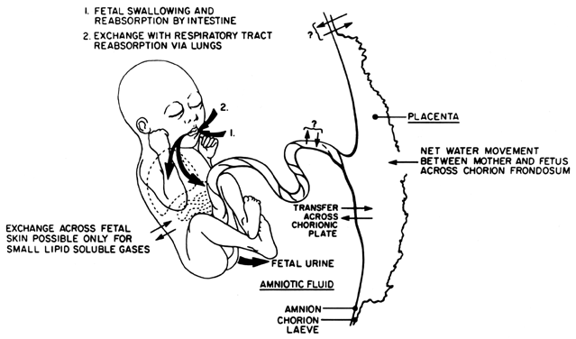
AMNIOTIC FLUID PRODUCTION
In the first half of pregnancy,
amniotic fluid is derived from fetal and possibly maternal compartments.
Water and solutes freely traverse fetal skin and may diffuse through the amnion and chorion as well.
Thus amniotic fluid in early gestation is a dialysate that is identical to the fetal and maternal plasma, but with a lower protein concentration.
Active secretion of fluid from the amniotic epithelium had been previously suggested to play a role in early amniotic fluid formation, but this has not been demonstrated.
By the second trimester,
the fetal skin becomes keratinized, making it impermeable to further diffusion. At this time, a fetus contributes to amniotic fluid volume and composition almost exclusively through urination.
Urine has been observed in the fetal bladder as early as 11 weeks transabdominally and 9 weeks transvaginally.
Because fetal urine is hypotonic (80–140 mOsm/ liter), it results in progressively hypotonic fluid (250–260 mOsm/liter near term) that contains increasing concentrations of urea, uric acid, and creatinine as the fetal kidneys mature.
By term, a fetus produces on average from 500 to 700 ml/day with a slight decline in hourly fetal urine production after 40 weeks' gestation.

AMNIOTIC FLUID IS ELIMINATED BY AT LEAST THREE MECHANISMS.
The primary source of elimination is through fetal swallowing, which has been observed as early as 16 weeks
on average, a fetus swallows from 200 to 450 ml/day at term, removing 50% of the amniotic fluid produced through fetal urination.
This fluid is absorbed through the fetal gastrointestinal system and is either recycled through the kidneys or is transferred to the maternal compartment through the placenta.
Amniotic fluid may also potentially be removed by continuous bulk flow (i.e., via hydrostatic and oncotic forces).
Exchange of fluid may take place at the chorionic plate, where exposure of the relatively hypotonic amniotic fluid to the fetal surface of the placenta may lead to net reabsorption of water by the fetus (up to 80 ml/day).
Transport across the amnion may occur through intercellular channels between amniotic epithelial cells and may be modulated by amniotic fluid prolactin levels
Amniotic fluid volume
Amniotic fluid volume is most predictable in the first half of pregnancy, when it correlates with fetal weight. This may relate to the predominant contribution of fetal skin dialysis to amniotic fluid volume between 8 and 20 weeks. At 12 weeks' gestation, the average volume is 60 ml. By 16 weeks, when genetic amniocentesis is often performed, the mean volume is 175 ml. From 20 weeks on, there is greater variance of amniotic fluid volume
amniotic fluid volume increases steadily throughout pregnancy to a maximum of 400–1200 ml at 34–38 weeks;
near term (500–700 ml/day through urine; 200–450 ml/day through deglutition), the net increase of amniotic fluid is only 5–10 ml/day in the third trimester. After 38 weeks, fluid volume declines by approximately 125 ml/week, to an average volume of 800 ml at 40 weeks
After 43 weeks, this volume is reduced to 250 ml

POLYHYDRAMNIOS, OR HYDRAMNIOS, is defined as an excessive volume of amniotic fluid relative to the gestational age.
Risk factors for hydramnios
Maternal conditions | Isoimmunization
 | Diabetes mellitus
Placental conditions | Chorioangioma
 | Circumvallate placenta
Fetal conditions
Multiple gestations | Twin-to-twin transfusion syndrome
Gastrointestinal | Esophageal atresia, duodenal or jejunal atresia, annular pancreas, midgut volvulus, diaphragmatic hernia, omphalocele, gastroschisis
CNS lesions | Anencephaly, hydrocephalus, encephalocele, spina bifida, microcephaly, hydranencephaly
Skeletal malformations | Arthrogryposis multiplex, osteogenesis imperfecta, thanatophoric dysplasia
Fetal tumors | Cystic adenomatoid malformation of the lung, sacrococcygeal teratoma, cervical teratoma
Cardiac disease | Severe congenital heart disease, fetal arrhythmias
Genetic disorders | Down syndrome, trisomy 13 and 18, Pena-Shokeir syndrome, multiple congenital anomalies, myotonia dystrophica
Fetal renal and endocrine disorders | Vasopressin insufficiency
Hematologic disorders | Homozygous α-thalassemia, fetomaternal hemorrhage
Intrauterine infections | Rubella, syphilis, toxoplasmosis, parvovirus
Miscellaneous | Nonimmune hydrops fetalis, fetal retroperitoneal fibrosis
Idiopathic

Diagnosis of Polyhydramnios
The diagnosis of polyhydramnios had formerly been a clinical one, retrospectively based on the presence of more than 2000 ml of amniotic fluid at the time of delivery or membrane rupture.
- Antenatal suspicion was raised by
- difficulty in palpating fetal parts,
- distant fetal heart sounds by unamplified auscultation,
- a tense uterine wall, and
- disproportionate growth of the fundal height.
- Historically, amniography was used to qualitatively assess amniotic fluid volume.

Medical management, including
- salt restriction
- diuretics, and
- intra-amniotic vasopressin

