The male reproductive system contains
- the external genitals (the penis, testes and the scrotum) and
- internal parts, including the prostate gland, vas deferens and urethra.

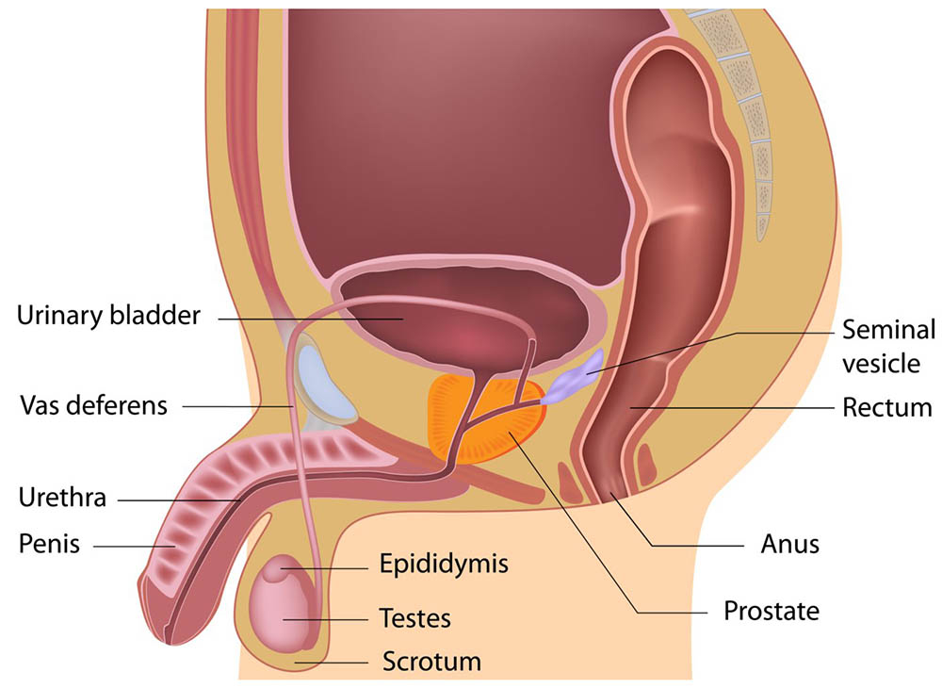

ORGANS AND FUNCTIONS
The male reproductive system is responsible for reproduction. It is made of the following parts:
- Penis — the organ used for urination and sexual intercourse. It has spongy tissue which can fill with blood to cause an erection. It contains the urethra, which carries both urine and semen.
- Scrotum — this is a loose bag of skin that hangs outside the body, behind the penis. It holds the testes in place.
- Testes (or testicles) — these are a pair of egg-shaped glands that sit in the scrotum, on the outside of the body. They produce sperm and testosterone, which is the male sex hormone.
- Epididymis — this is a highly coiled tube that lies at the back of the testes. All sperm from the testes must pass through the epididymis, where they mature and start to ‘swim’.
- Vas deferens — this is a thick-walled tube joined to the epididymis. It carries sperm from the epididymis up to the prostate gland and urethra.
- Prostate gland — this is a walnut-sized gland that sits in the middle of the pelvis. The urethra runs through the middle of it. It produces the fluid secretions that support and nourish the sperm.
- Urethra — this is a tube that extends from the bladder to the external opening at the end of the penis. The urethra carries both urine and sperm.
- Seminal vesicles — these are 2 small glands above the prostate gland that make up much of the fluid in semen.

